**TABLE OF CONTENTS**

Sr No. Title Page no.

Synopsis

Title of Project 1

Why this topic? 1

Objective 1

Scope 2

Methodology 2

Architecture 2

Requirements 3

Contribution 3

Conclusion 4

CHAPTER 1 Introduction to System

1.1 Background 5

1.2 Objectives 5

1.3 Purpose, Scope and Applicability 5

1.3.1 Purpose 5

1.3.2 Scope 5

1.3.3 Applicability 5

CHAPTER 2 Survey of Technology

2.1 Front End Technologies 7

2.2 Back End Technologies 7

2.3 Databases 8

2.4 Why These Languages 8

CHAPTER 3 Requirement and Analysis

3.1 Problem Definition 9

3.2 Requirement Specification 9

3.2.1 Requirement Gathering 9

3.2.2 Requirement Analysis 11

3.2.2.1 Functional Requirements 11

3.2.2.2 Non-Functional Requirements 12

3.2.2.3 System Requirements 12

3.2.3 Planning and Scheduling 14

CHAPTER 4 System Design

4.1 Entity Relationship Diagrams 17

4.1.1 Entity Sets 17

|  |  |  |
| --- | --- | --- |
|  | 4.1.2 Relationship Sets | 18 |
|  | 4.1.3 ER Diagram | 20 |
|  | 4.2 Schema | 21 |
|  | 4.3 Module Diagram | 22 |
|  | 4.4 Data Flow Diagram | 24 |
|  | 4.4.1 Level O (Context Level DFD) | 24 |
|  | 4.4.2 First Level DFD | 25 |
|  | 4.4.3 Second Level DFD | 26 |
|  | 4.4.3.1 Level 2 DFD for check availability | 26 |
|  | 4.4.3.2 Level 2 DFD for booking management | 26 |
|  | 4.4.3.3 Level 2 DFD for Payment management | 27 |
|  | 4.5 Use Case | 28 |
|  | 4.5.1 Use Case Diagram | 28 |
|  | 4.5.2 Use Case Description | 28 |
|  | 4.5.3 Use Case Scenarios | 32 |
|  | 4.6 Sequence Diagram | 35 |
|  | 4.6.1 Login | 35 |
|  | 4.6.2 Booking | 35 |
|  | 4.6.3 Payment | 36 |
|  | 4.6.4 Cancel Booking | 36 |
|  | 4.6.5 Check Availability | 37 |
|  | 4.7 Activity Diagram | 38 |
|  | 4.8 User Interface | 39 |
|  | 4.9 Test Cases | 45 |
| CHAPTER 5 | Implementation and Testing |  |
|  | 5.1 Implementation Approaches | 47 |
|  | 5.2 Coding Details and Coding Efficiency | 48 |
|  | 5.2.2 Coding | 48 |
|  | 5.2.3 Coding Efficiency | 55 |
|  | 5.3 Testing Approach | 55 |
|  | 5.4 Unit Testing | 56 |

|  |  |  |
| --- | --- | --- |
| CHAPTER 6 | Results and Discussions |  |
|  | 6.1 Test Reports | 61 |
|  | 6.2 User Documentation | 62 |
| CHAPTER 7 | Conclusion and Future Work |  |
|  | 7.1 Conclusion | 69 |
|  | 7.2 Limitations of the System | 69 |
|  | 7.3 Future Scope of the Projects | 70 |
|  | Reference | 71 |

**List of Tables**

|  |  |  |
| --- | --- | --- |
| **Table no** | **Table name** | **Page no** |
| Table 3.1 | Task Table | 16 |
| Table 4.1 | Test cases Table | 45 |
| Table 5.1 | Unit Testing of Registration | 57 |
| Table 5.2 | Unit Testing of Login | 58 |
| Table 5.3 | Unit Testing of Forgot Password | 59 |

**List of Figures**

|  |  |  |
| --- | --- | --- |
| Figure no | Figure name | Page no |
| Figure 3.1 | Gantt chart | 16 |
| Figure 4.1 | Owner Barbershop Entity set | 18 |
| Figure 4.2 | Barbershop barber entity set | 19 |
| Figure 4.3 | Employee Booking Entity set | 19 |
| Figure 4.4 | Booking service entity set | 19 |
| Figure 4.5 | Booking payment entity set | 20 |

|  |  |  |
| --- | --- | --- |
| Figure 4.6 | ER Diagram | 20 |
| Figure 4.7 | Schema | 21 |
| Figure 4.8 | Module Diagram | 22 |
| Figure 4.9 | Context Level DFD | 24 |
| Figure 4.10 | First Level DFD | 25 |
| Figure 4.11 | Second Level DFD for check availability | 26 |
| Figure 4.12 | Second Level DFD for Booking Management | 26 |
| Figure 4.13 | Second Level DFD for Payment Management | 27 |
| Figure 4.14 | Use case Diagram | 28 |
| Figure 4.15 | Sequence Diagram for Admin Login | 35 |
| Figure 4.16 | Sequence Diagram for Booking for customer | 35 |
| Figure 4.17 | Sequence Diagram for Payment method for customer | 36 |
| Figure 4.18 | Sequence Diagram for Cancel Booking for customer | 36 |
| Figure 4.19 | Sequence diagram for check availability | 37 |
| Figure 4.20 | Activity Diagram | 38 |
| Figure 4.21 | Registration page for customer | 39 |
| Figure 4.22 | Login page for customer | 39 |
| Figure 4.23 | Forgot password for Customer | 40 |

|  |  |  |
| --- | --- | --- |
| Figure 4.24 | Reset Password page for Customer | 40 |
| Figure 4.25 | Dashboard page for customer | 41 |
| Figure 4.26 | Appointment Booking for customer page | 42 |
| Figure 4.27 | Login page for Admin | 42 |
| Figure 4.28 | Dashboard page for admin | 43 |
| Figure 4.29 | Manage customer for admin | 43 |
| Figure 4.30 | Add customer for admin | 43 |
| Figure 4.31 | Manage Booking for admin | 44 |
| Figure 6.1 | Login page for customer | 62 |
| Figure 6.2 | Registration page for customer | 62 |
| Figure 6.3 | Forgot password for Customer | 63 |
| Figure 6.4 | Reset Password page for Customer | 63 |
| Figure 6.5 | Dashboard page for customer | 64 |
| Figure 6.6 | Appointment Booking for customer page | 65 |
| Figure 6.7 | Login page for Admin | 65 |
| Figure 6.8 | Dashboard page for admin | 66 |
| Figure 6.9 | Manage customer for admin | 66 |
| Figure 6.10 | Add customer for admin | 67 |
| Figure 6.11 | Manage customer for admin | 67 |

**SYNOPSIS**

**­­**

* **Title:-**Barbershop Management System
* **Project Description :-**

1. The Barbershop Management System is a comprehensive website designed to simply and automate various aspects of barbershop management operations.
2. It includes features such as appointment scheduling, customer management, inventory control, staff management, transactions with features like online booking, staff scheduling.
3. The system empowers barbershop owners to optimize their operations, enhance customer experiences and drive business growth.

* **Why This Topic ? :-**

1. In the modern age, Barbershop face numerous challenges, including efficient scheduling, customer relationship management, staff scheduling and keeping up with digital demands
2. This system aims to address this challenges by providing a seamless platform that ensures appointments are organized, well maintained inventory control, staff schedules are optimize and customer interactions are personalized.

* **Objectives:-**

1. Appointment scheduling :- The Barbershop management system aims to streamline the process of scheduling appointments, allowing customers to easily book reschedule or cancel appointment online.
2. Customer management :- The system is designed to help barbershops better manage their customer relationships.
3. Inventory Control :- This system includes tools for automating recorders and generating reports on service sales.
4. Staff Management :- The system offers features for managing staff schedules, tracking performance and facilitating communicaton.
5. Transactions :- The system includes a point of sale module that supports various payment methods, generate reports and track sales data.
6. User-friendly Platform :- The system is designed to be intuitive and easy to use ensuring that staff can quickly learn and adopt platform.

* **Scope :-**

The system will cover various aspects of barbershop operations, including

appointment scheduling, customer management, inventory control, staff

management system, transactions all over in the India.

* **Methodology :-**

For developing this system I use an Iterative approach because :

1. Flexibility :- An Iterative approach allows for changes to be made throughout the development process. This is particularly useful in web development, where requirements and user needs can change rapidly
2. User Feedback :- by building the website in small increments you can gather user feedback early and often. This feedback can be used to improve the website and ensure that it meets the needs of this users.
3. Risk Deduction :- An Iterative approach can help reduce the risk of project failure by identifying and addressing issues early on. By breaking the project down into smaller pieces, you can more easily identify potential problems and make adjustments as needed.
4. Faster time to market :- By Building the website in small increments, you can release features and updates more quickly. This can help you get your product to market faster and start generating revenue sooner.

* **Proposed Architecture :-**

The proposed architecture involves a client – server model

1. Client – Server :-
   * + - * Frontend : PHP, CSS and Javascript frameworks such as ASP.NET for user interface
         * User Interface : Provides a responsive and intuitive interface for clients and barbers to interact with the system.
2. Server side :-
   * + - * Business logic :- implements business logic to handle operations such as appointment scheduling, client management, inventory tracking and data analysis.
         * Database :- Uses a relational database management system like SQL to store and manage data related to clients, appointments, services and inventory.The client server architecture ensures separation of concerns, with the Frontend responsible for user interactions and presentation, while the Backend handles business logic, data management.

* **Requirements**
* Hardware Requirements:

Processor: AMD Ryzen S2004 or Intel i3 or newer

RAM: 4GB-2GB

Hard Disk: 256GB SSD

Monitor: 1200x800 Screen Resolution

* Software Requirements:

Frontend: HTML, CSS, JavaScript

Backend: C#

Database: SQL

* Platform:

Visual Studio Code

* **Contribution:-**

1. Empowering Small Businesses: By providing tools to streamline small barbershop operations, the website empowers small barber shops to compete more effectively in the market, potentially leading to increased success and sustainability for these businesses.
2. Improving Efficiency: The system helps barbershops optimize their scheduling, inventory management, and client interactions, ultimately saving time and resources. This efficiency can lead to better service for customers and improved productivity for barbers.
3. Enhancing Customer Experience: With features like online booking, the website enhances the overall customer experience, making it easier and more convenient for clients to engage with their barbershop.
4. Promoting Digital Literacy: By adopting digital tools for business management, barbers and shop owners can improve their digital literacy, enabling them to adapt to technological advancements and stay competitive in a rapidly changing world.

* **Conclusion:-**

This website offers a comprehensive solution for modernizing and optimizing barbershop operations. By streamlining scheduling, enhancing customer interactions, and improving overall efficiency, the website empowers small businesses to compete effectively in the market while providing a better experience for clients.

**Chapter 1: Introduction**

* 1. **Background:**

The Barbershop Management System is a website designed to solve the various problems of barbering businesses, such as appointment scheduling, customer management, inventory control, staff management, and transactions. The system empowers barbershop owners to optimize their operations, enhance customer experiences, and drive business growth. The development of the Barbershop Management System may involve requirements gathering, design, coding, testing, and deployment.

**1.2 Objectives**:

1. 1.Appointment Scheduling: Customers can book, reschedule, and cancel their appointments.
2. 2.Customer Management: Barbers can manage their customers online.
3. 3.Inventory Control: The system includes tools for tracking inventory levels, automating the generation of reports on sales.
4. 4.Staff Management: The system offers features for managing staff schedules.
5. 5.Transactions: The system includes the point of sale module that supports various payment methods, generates receipts, and tracks data
   1. **Purpose Scope and Applicability:**

**1.3.1 Purpose:**

A Barbershop Management System helps barbershops to manage appointments, payments, client information, marketing promotions, inventory, and transactions. It can streamline operations, improve customer experience, and provide valuable insights for business growth.

* + 1. **Scope:**

The system will cover various problems of barbershop operations, including appointment scheduling, customer management, inventory control, staff management, and transactions all over in Mumbai.

* + 1. **Applicability:**

A barbershop management system website is applicable for barbershop management systems to streamline their operations and enhance customer experiences. It offers features such as appointment scheduling, customer management, inventory control, staff management, and transactions. By implementing such a system, barbershop owners can optimize their operations, improve customer interactions, and make data-driven decisions to drive business growth

.

**Chapter 2 :**

**Survey of Technology**

**2.1 Front-end Technologies**

1. HTML5: HTML5 is a markup language used for structuring and presenting content on the World Wide Web. HTML5 includes detailed processing models to encourage more interoperable implementations, extends, improves, and rationalizes the markup available for documents, and introduces markup and application programming interfaces (APIs) for complex web applications.
2. CSS: Cascading Style Sheets (CSS) is a style sheet used for describing the presentation of a document written in a markup language such as HTML. CSS is a cornerstone technology of the World Wide Web, alongside HTML and JavaScript. CSS is designed to enable the separation of the presentation and content, including layout, colors, and fonts. This separation can improve content accessibility, provide more flexibility and control in the specification of presentation characteristics, enable multiple web pages to share formatting by specifying the relevant CSS in a separate CSS file which reduces complexity and repetition in the structural content, as well as enabling the CSS file to be cached to improve the page load speed.
3. JavaScript: JavaScript is the programming language for the web. JavaScript can update and change both HTML and CSS. JavaScript can calculate, manipulate, and validate data. It is a dynamic computer programming language. It is lightweight and most commonly used as a part of web pages, whose implementations allow client-side scripts to interact with the user and make dynamic pages. It is an interpreted programming language with object-oriented capabilities.
   1. **Back-end Technologies:-**

**PHP:**

1. PHP (recursive acronym for PHP: Hyper Text Preprocessor) is a widely used open source, general-purpose scripting language that is especially suited for web development. It can be embedded into HTML. PHP is a server-side scripting language that is used to develop
2. PHP scripts can only be interpreted on a server that has PHP installed.
3. Reason for choosing these languages:
4. I am going to use HTML, CSS, JavaScript, and ASP.NET as front-end languages to create a user-friendly front-end of my system. CSS will be helpful for presentation, and JavaScript will help me manipulate, calculate, and validate data which is used for the system.
5. For the back-end development of my system, I am going to use MySQL, PHP. I believe that these languages are easy to learn and use for storing the data in the database, server, and also retrieving and modifying the data stored in the database. Using these back-end languages, addition, deletion, and manipulation of data is easy to manage.
   1. **Databases:**

**MySQL**:

MySQL is a relational database management system (RDBMS) developed by Oracle that is based on structural query language (SQL). MySQL is a fast, easy-to-use RDBMS being used for many small and big businesses. MySQL provides an implementation of a SQL database very well suited for small to medium web pages. A database is just a structured collection of data that is organized for easy use and retrieval. Common applications for MySQL include PHP and Java-based web applications that require a DB storage backend.

* 1. **Why These Languages:**

This topic is essential for understanding the core technologies involved in web development, covering both front-end and back-end aspects along with database management. The selection of HTML, CSS, JavaScript, and ASP.NET for the front end ensures an interactive, visually appealing, and user-friendly interface. Meanwhile, PHP and MySQL are chosen for the back-end development, as they offer efficient data storage, retrieval, and manipulation capabilities. These technologies collectively provide a strong foundation for building dynamic and scalable web applications. By integrating these tools, the system can achieve a seamless user experience while maintaining efficiency and security in data management.

**Chapter 3 :**

**Requirements and Analysis**

**3.1 Problem Definition:**

This system is built to make an online appointment for the barbershop. Select a specific barber and add the service whichever customer wants. This system will grow the barbershop business in the society where today all the things are becoming online competitive in today's market.

The system should maintain the database of customer information including scheduling features that allow customers to schedule. Database includes contact details, appointment history.

The system will help the barbershop manage their appointments more efficiently, provide personalized services to customers.

* 1. **Requirement Specification:**

**3.2.1 Requirements gathering:**

For my system, I have used google form to collect feedback to the responses from users according to the responses.

1. **Booking preference:**

How would you prefer to book your appointments?

1. Online booking through the website
2. Phone calls or walk-ins only
3. Both online and offline options
4. **Appointment Flexibility:**

How far in advance would you like to be able to book appointments?

1. Same day only
2. Up to 2 days in advance
3. Up to 1 week in advance
4. **Service selection:**

How do you prefer to select your services when booking appointments?

1. Dropdown menu with predefined services
2. Customizable options for each service
3. Combination of both
4. Payment options: What payment methods would you like to see available?
5. Credit/debit card
6. Cash
7. Online payment gateways (e.g., PayPal, Stripe)
8. **Appointments Reminders:**

How would you like to receive reminders for your appointments?

1. Email
2. SMS/Text message
3. Push notification through the website
4. Feedback Preference: How would you prefer to provide feedback about your experience?
5. Online feedback form on the website
6. Paper feedback forms in the shop
7. Follow-up emails after appointments
8. **Design style:**

What design style would make you feel most comfortable and welcome on the website?

1. Modern and minimalist
2. Classic and elegant
3. Funky and vibrant
4. **Mobile Experience:**

How important is it for you that the website is easy to use on mobile devices?

1. Very important
2. Somewhat important
3. Not important
4. **Content Preferences:**

What type of content would you like to see on the website?

1. Barber profiles and ratings
2. Blog articles on grooming tips and trends
3. Customer reviews
4. **Appointment History:**

Would you like to have access to your appointment history on the website?

1. Yes
2. No
3. **Ease of use:**

How important is it for you that the website is intuitive and easy to navigate?

1. Very important
2. Somewhat important
3. Not important

**3.2.2 Requirement Analysis**

* + - 1. **Functional Requirements:**

1. Customer Management:
2. The system should allow barbers to create and manage customer profiles, including contact information and appointment history.
3. The system should enable customers to book appointments online or through the barbershop website.
4. Appointment Scheduling:
5. The system should allow barbers to schedule appointments and manage their availability.
6. Service Management:
7. The system should allow barbers to create and manage services offered, including pricing and duration.
8. The system should enable customers to select services when booking an appointment.
9. Payment Processing:
10. The system should allow barbers to manage customer payments for services online or in-person.
11. The system should integrate with payment gateways to process transactions securely.
12. Inventory Management:
13. The system should allow barbers to manage inventory of products and supplies.
14. The system should alert barbers when inventory levels are low.
    * + 1. **Non-Functional Requirements:**
15. Performance:
16. The system should respond to user input within 2 seconds.
17. The system should be able to handle a minimum of 100 concurrent users.
18. Security:
19. The system should encrypt sensitive customer data, such as payment information.
20. The system should comply with industry standards for data security and privacy.
21. Usability:
22. The system should be easy to use for barbers and customers with minimal training.
23. The system should provide clear and concise instructions for each feature.

Availability:

1. The system should be available 24/7, with a minimum of 99.9% uptime.
2. The system should have a backup and disaster recovery plan in place.
   * + 1. **System Resuirements:**

#### **1.1 User Registration & Login**

* **Input:** Name, Contact Number, Email, Password
* **Output:** Account successfully registered & login granted
* **Action:** Users must register before booking appointments
* **Pre-condition:** User must provide valid details
* **Post-condition:** Users can log in and access features
* **Exception:** Invalid or missing input will show an error

#### **1.2 Appointment Booking**

* **Input:** Date, Time, Service Type, Barber Selection
* **Output:** Appointment successfully booked
* **Action:** Users can book an available time slot with a barber
* **Pre-condition:** The barber and time slot must be available
* **Post-condition:** The appointment is confirmed and stored in the database
* **Exception:** If the selected slot is already booked, an error is displayed

#### **1.3 Appointment Cancellation**

* **Input:** Select appointment to cancel
* **Output:** Appointment successfully canceled
* **Action:** Users can cancel booked appointments
* **Pre-condition:** The appointment must exist in the system
* **Post-condition:** The slot becomes available for other users
* **Exception:** If the appointment does not exist, an error is displayed

#### **1.4 Service Selection**

* **Input:** User selects the desired service (e.g., Haircut, Shaving, Hair Coloring)
* **Output:** Service details and price displayed
* **Action:** Users can view and choose services
* **Pre-condition:** Services must be available in the system
* **Post-condition:** Selected service is added to the booking
* **Exception:** If service is not available, an error is displayed

#### **1.5 Payment Processing**

* **Input:** Payment method (Credit/Debit Card, UPI, Cash on Arrival)
* **Output:** Payment confirmation
* **Action:** Users pay for services before or after the appointment
* **Pre-condition:** Users must have a valid payment method
* **Post-condition:** Payment is stored in the database, and the booking is confirmed
* **Exception:** Payment failure due to incorrect details or transaction issues

### 3.2.3 Planning and Scheduling

|  |  |  |  |  |  |
| --- | --- | --- | --- | --- | --- |
| **Task no.** | **Task Name** | **Allocated**  **Date** | **End Date** | **Actual**  **Start Date** | **Actual**  **End Date** |
| T1 | Project Approval | 05/04/24 | 16/04/24 | 07/04/24 | 13/04/24 |
| T2 | Project Synopsis | 13/04/24 | 16/04/24 | 15/04/24 | 16/04/24 |
| T3 | Chapter-1: Introduction | 16/04/24 | 20/04/24 | 17/04/24 | 19/04/24 |
| T4 | Chapter-2: Survey of technology | 20/04/24 | 11/06/24 | 29/05/24 | 14/06/24 |
| T5 | Chapter-3:  Requirement Analysis a) Problem Definition  b) Requirement Specification | 20/04/24 | 11/06/24 | 21/04/24 | 14/06/24 |
| T6 | 3.4 Task Table | 13/04/24 | 28/09/24 | 13/04/24 | 28/09/24 |
| T7 | Chapter-4: System  Design  4.1 ER Diagram | 22/06/24 | 28/06/24 | 22/06/24 | 27/06/24 |
| T8 | 4.2 Schema Diagram | 03/07/24 | 06/07/24 | 04/07/24 | 05/07/24 |
| T9 | 4.3Module Diagram | 06/07/24 | 10/07/24 | 08/07/24 | 09/07/24 |
| T10 | 4.4 Data Flow Diagram | 10/07/24 | 29/07/24 | 11/07/24 | 16/07/24 |
| T11 | 4.5 Use Case Diagram and Scenarios | 22/07/24 | 27/07/24 | 23/07/24 | 25/07/24 |
| T12 | 4.6 Sequence Diagram | 09/08/24 | 14/08/24 | 11/08/24 | 13/08/24 |
| T13 | 4.7 Activity Diagram | 03/09/24 | 06/09/24 | 04/09/24 | 05/09/24 |
| T14 | 4.8 User interface diagram | 20/09/24 | 25/09/24 | 20/09/24 | 22/09/24 |
| T15 | 4.9 Test Cases | 20/09/24 | 28/09/24 | 23/09/24 | 24/09/24 |

|  |  |  |  |  |  |
| --- | --- | --- | --- | --- | --- |
| **Task no.** | **Task Name** | **Allocated**  **Date** | **End Date** | **Actual**  **Start Date** | **Actual**  **End Date** |
| **Re-engineering** | | | | | |
| T1 | Chapter 1 | 13/11/24 | 20/11/24 | 14/11/24 | 20/11/24 |
| T2 | Chapter 2 | 13/11/24 | 20/11/24 | 15/11/24 | 21/11/24 |
| T3 | Chapter 3 | 13/11/24 | 20/11/24 | 15/11/24 | 21/11/24 |
| T4 | Chapter 4 | 14/11/24 | 20/11/24 | 16/11/24 | 22/11/24 |
| **Module 1: Login page** | | | | | |
| T5 | Coding | 24/11/24 | 3/12/24 | 26/11/24 | 28/12/24 |
| **Module 2: Registration for Customers and Admin** | | | | | |
| T6 | Coding, Testing &  Debugging | 29/11/24 | 4/12/24 | 29/11/24 | 30/11/24 |
| **Module 3: Login for Customers and Admin** | | | | | |
| T7 | Coding, Testing &  Debugging | 27/11/24 | 6/12/24 | 28/11/24 | 4/12/24 |
| **Module 4: Customer Dashboard** | | | | | |
| T8 | Coding, Testing &  Debugging | 7/12/24 | 15/12/24 | 9/12/24 | 12/12/24 |
| **Module 5: Artist Dashboard** | | | | | |
| T9 | Coding, Testing &  Debugging | 26/12/24 | 28/12/24 | 27/12/24 | 30/12/24 |
| **Module 6: Artist Customer Management (add, update and delete products)** | | | | | |
| T10 | Coding, Testing &  Debugging | 29/12/24 | 30/12/24 | 28/12/24 | 29/12/24 |
| **Module 7: Customer Booking page** | | | | | |
| T11 | Coding, Testing &  Debugging | 01/01/25 | 04/01/25 | 03/01/25 | 05/01/25 |
| **Module 8: Admin Manage Booking Page** | | | | | |
| T12 | Coding, Testing &  Debugging | 12/01/25 | 19/01/25 | 14/01/25 | 20/01/25 |
| **Module 9: Checkout Page** | | | | | |
| T13 | Coding, Testing &  Debugging | 21/01/25 | 24/01/25 | 22/01/25 | 23/01/25 |
|  |  | **Module 14: Payment** | |  |  |
| T14 | Coding, Testing &  Debugging | 14/02/25 | 18/02/25 | 13/02/25 | 17/02/25 |

***Table 3.1 Task Table***

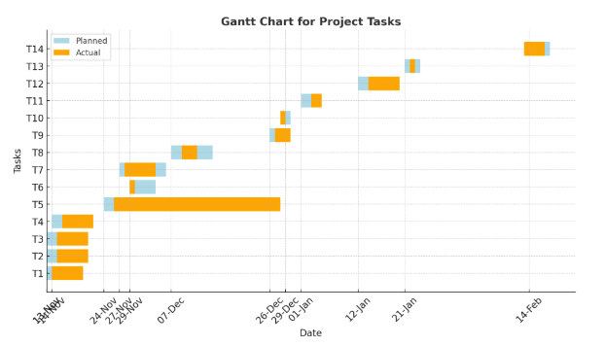

***Figure 3.1 Gantt Chart***

\

**Chapter 4 : System Design**

**4.1.1 Entity Set for Barbershop Management System**

1. Owner: The owner of the barbershop.
2. Employee: The employees work in that barbershop.
3. Customer: The customers of that barbershop.
4. Appointment: Appointment booked by the customer.
5. Services: The service which customer needs.
6. Payments: The payment done by the customer.
7. Products: The product used for a specific service.
8. Inventory: The inventory levels of products.
9. Barbershop: The barbershop owned by the owner.

**Attributes:**

1. Owner:
2. Owner_id (Primary key)
3. Owner_name
4. Contact_no.
5. Email
6. Address
7. Employee:
8. Employee_id (Primary key)
9. Employee_name
10. Employee_Mobile
11. Email
12. Salary
13. Employee_Email
14. Employee_Address
15. Customer:
16. Customer_Id (Primary key)
17. Customer_name
18. Customer_address
19. Customer_Mobile
20. Customer_Email
21. Appointment:
22. Appointment_ID (Primary key)
23. Appointment_Date
24. Appointment_Time
25. Customer_ID (Foreign key)
26. Service:
27. Service_ID (Primary key)
28. Service_name
29. Product_ID (Foreign key)
30. Employee_ID (Foreign key)
31. Payment:
32. Payment_ID (Primary key)
33. Payment_method
34. Payment_Time
35. Payment_Amount
36. Product:
37. Product_ID (Primary key)
38. Product_name
39. Product_description
40. Product_Quantity
41. Inventory:
42. Inventory_id (Primary key)
43. Product_id (Foreign key)
44. Inventory_Qty
45. Barbershop:
46. Barbershop_id (Primary key)
47. Name Barbershop_name
48. Address Barbershop_Address
49. Capacity
    * 1. **Relationship sets:-**
50. **Owner - Barbershop:**

An owner owns a barbershop.

Type: one-to-one

Participation:

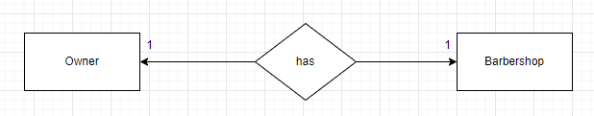

1. **Barbershop - Barbers Employee:**

A barbershop has multiple barbers/employees.

Type: one-to-many

Participation:

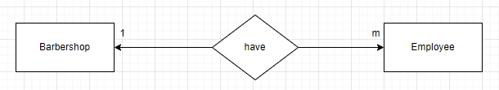

1. **Employee - Appointment:**

A barber has multiple appointments.

Type: one-to-many

Participation:

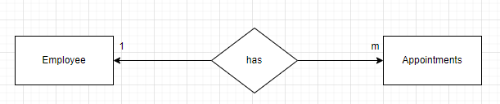

1. **Appointment - Service:**

An appointment is for one service, and an appointment can be requested by multiple services.

Type: many-to-one

Participation:

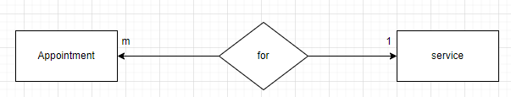

1. **Appointment - Payment:**

An appointment is associated with one payment, and a payment is associated with one appointment.

Type: one-to-one

Participation:

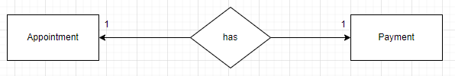

**4.1.3Entity-Relationship Diagram:-**

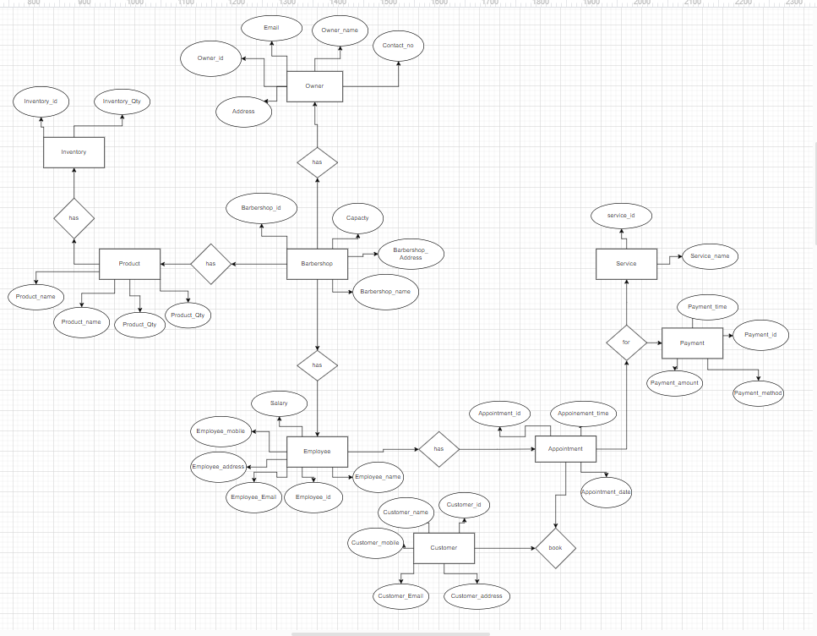

***Figure 4.6: Entity-Relationship Diagram***

* 1. **Schema Diagram:-**

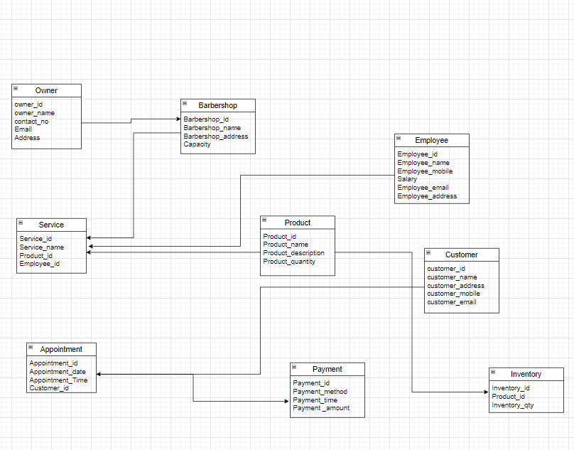

***Figure 4.7:Schema Diagram***

* 1. **Module Diagram:-**

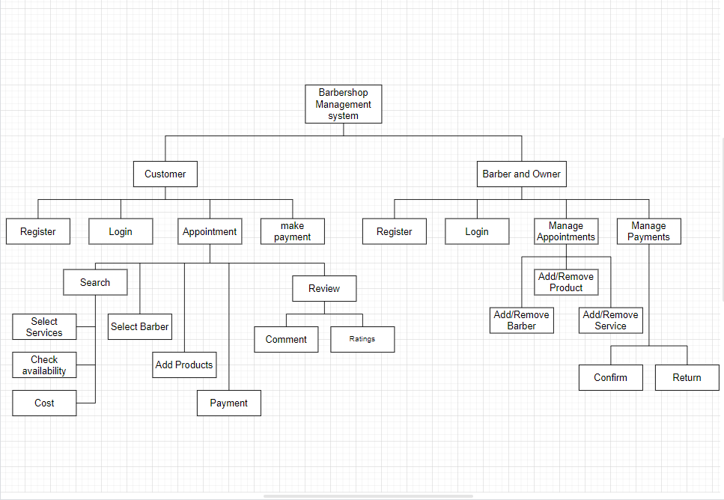

***Figure 4.8:Module diagram***

1. **Description:**

A web-based application for barbershop management.

1. Authentication:
2. Login: Allows Barbers, Owners, and Customers to login through Username and Password.
3. Register: Allows new customers to create their account by providing personal details (e.g., Name, Phone, Email, set Password).
4. Owner:
5. Generate Reports: Generates reports and analytics for sales, appointments, inventory, etc.
6. Check Product Availability: Owner can manage product listings and track inventory levels.
7. Add/Remove Barbers: Owner can Add or Remove Barbers according to their service requirements.
8. Add/Remove Products: Owner can Add or Remove Products according to their Products Inventory Availability.
9. Add/Remove Services: Owner can Add or Remove Services according to the Barbers' Speciality& Customer Requirements.
10. Manage Appointments: Owner can view, modify, and
11. Manage Customer Appointments: Owner can track and manage all payment transactions.
12. Barbers:
13. Check Appointments: Barbers can check their appointments to make themselves available for the services.
14. Add/Remove Products: Barbers can view products availability and add or remove products according to that.
15. Add/Remove Services: Barbers can add or remove services according to their specialty.
16. Customers:
17. Book Appointment: Book an appointment with chosen barbers, services, and time.
18. Make Payment: Integration with payment gateways for customers to pay for services and products.
19. Check Availability: Customers can check barbers' availability for the specific time.
20. Track Appointments: Customers can check their appointment status.
21. Cancel Appointment: Customers can cancel their appointments.
22. Make Reviews: Customers can give ratings to the
23. Services provided by the barber and barbershop
24. Browse Services & Products: Customers can view and select from available services and products.
25. View Appointment History: Customers can view their past and upcoming appointments.

**4.4DFD – Diagram  
4.4.1 Context level [level 0]:-**

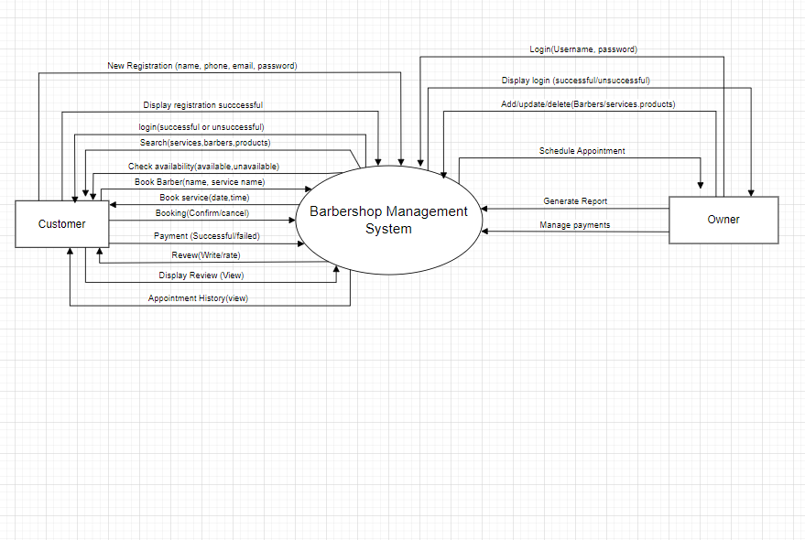

***Figure 4.9:DFD – Diagram Context level [level 0]***

* + 1. **DFD level 1:-**

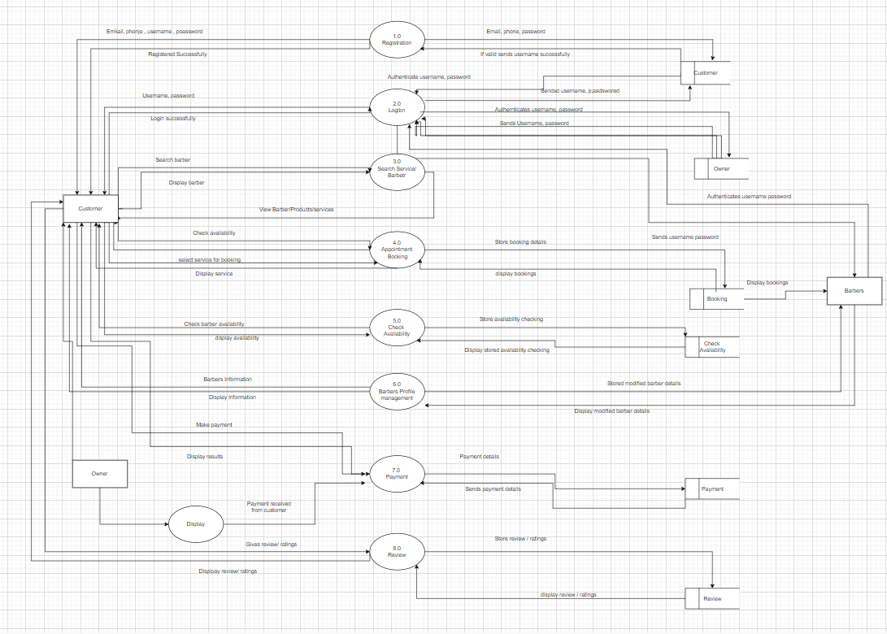

***Figure 4.10:DFD level 1***

* + 1. **DFD Level 2 :-**

**4.4.3.1 Level 2 DFD for check availability**

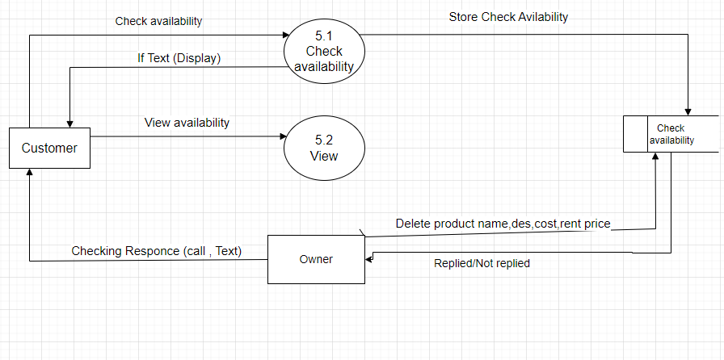

***Figure 4.11:DFD level 2 for Check Availability Management***

**4.4.3.2 Level 2 DFD for booking management**

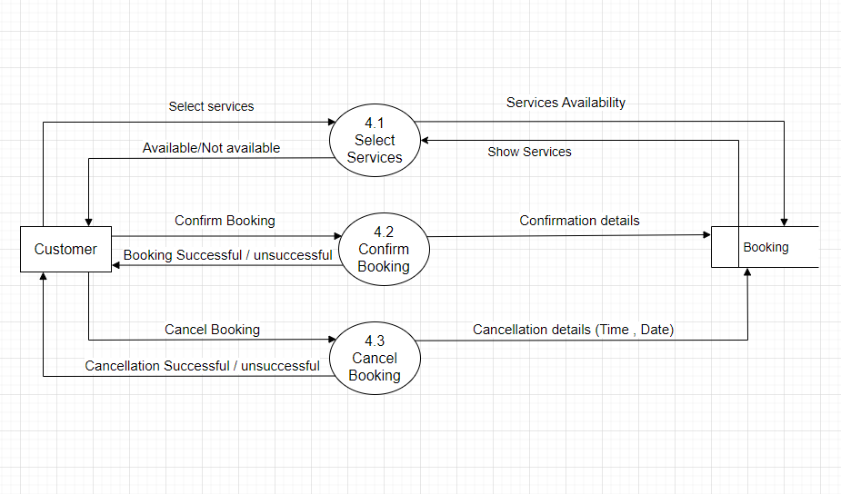

***Figure 4.12:DFD level 2 for Booking management***

**4.4.3.3 Level 2 DFD for Payment management**

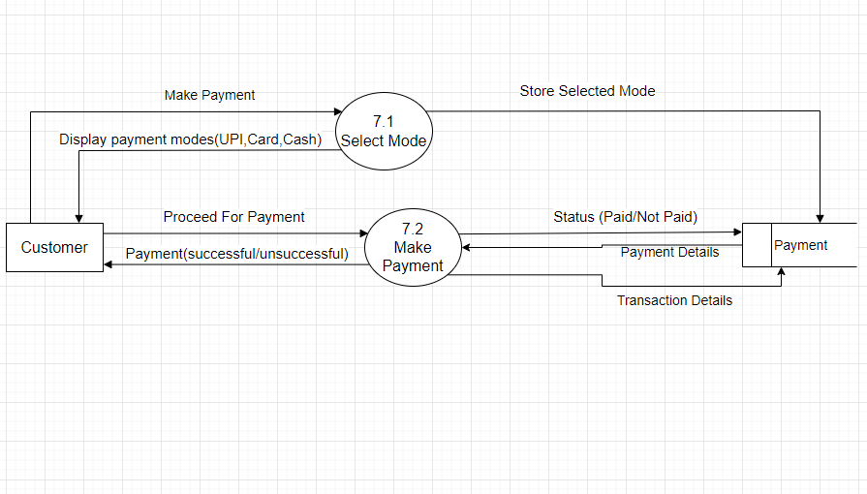

***Figure 4.13:DFD level 2 for Payment management***

* 1. **Use Case :-**

**4.5.1: Use Case diagram:**

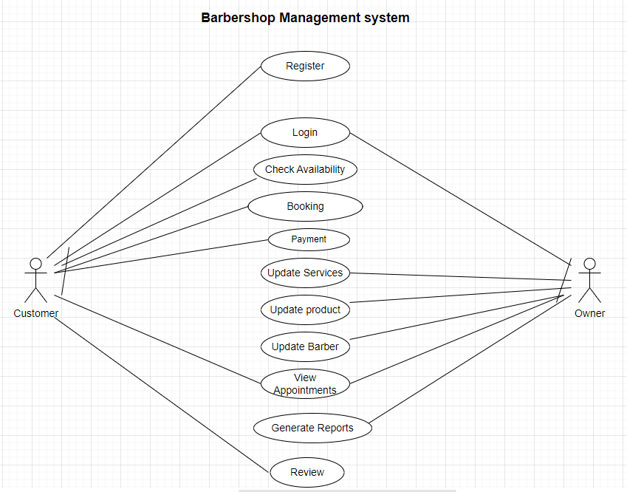

***Figure 4.14:Use Case***

* + 1. **Description:-**

**Use Case: Registration**

1. Summary: The customer enters his/her details. If the details are valid, then the user details are stored.
2. Actors: Customer
3. Pre-conditions: The user should not be pre-logged in.
4. Description:

The user accesses the system. The system presents the registration form with some required fields (full name, email, contact, password). The user fills the information. The system validates the fields. If the user validation is successful, then the system creates a new account and displays a confirmation message to the user indicating successful registration.

**Exception:**

1. The user is already registered: If the corresponding user is already registered, then "already registered" message shows up.
2. Post-conditions:If the registration was successful, then the login page is shown; else, the user stays on the same page.

**Use Case: Login**

1. Summary: The user who has registered and created an account can log in the system.
2. Actors: Customer, Owner, Barber
3. Pre-conditions: The user has already registered an account.
4. Description:
   * 1. The actor enters the details. The details are verified by the system. If the verification is successful, the login state is saved to the actor, and the message "login successful" is displayed to the actor.
5. Exceptions:
   * 1. Invalid credentials: If the actor details are incorrect, then the system displays "error message: incorrect credentials."
6. Post-conditions:
   * 1. The actor is successfully logged in and browses services, books appointments, and other features.
     2. The owner can have the look of reviews and bookings.

**Use Case: Check Availability**

1. Summary:

A user can check the availability of the barbers and the services provided by the barbershop, and also checks the specialty of the barbers for a specific service.

1. Actor: Customer
2. Pre-conditions: The customer should be logged in to the system to access the system.
3. Post-conditions: The user can view all the information regarding to the services, standards, and barber specialty.

**Use Case: Booking**

1. Summary: The user/customer can book their services and cancel too.
2. Actor: Customer
3. Pre-conditions: The customer must be logged in to the system. The customer must have at least one service booked.
4. Description: The customer can book an appointment for a particular date and time and barber.
5. Exception: The selected date and time at which the selected barber is unavailable.
6. Post-conditions: The system generates a booking confirmation and redirects to the payment procedure.

**Use Case: Payment**

1. Summary: After completing the booking, it displays the procedure of payment of the respective service.
2. Actor: Customer
3. Pre-conditions: The user needs to select a serviceservice proceeding for payment.
4. Description:
   * 1. Customer selects services, enters payment details.
     2. System processes payment through the payment transaction and displays payment success and sends a receipt.
5. Exception:
   * 1. Payment failure: Invalid payment details or transaction method or system notifies customer to retry or use another method.
6. Post-condition:
   * 1. Payment is successfully processed, booking is confirmed, receipt is sent to the customer, service details are updated accordingly.

**Use Case: Review**

1. Summary:
   * 1. The customer provides feedback and sends a review for a service visit and experience at the barbershop.
2. Actor: Customer
3. Pre-conditions: Customer must be logged in to the system.
4. Description:
   * 1. After taking the service, the customer can go to the review section and can give the review for the service provided to him/her.
5. Exception: None
6. Post-conditions: Successful review gets uploaded and stored in the database, and other customers may view while booking the services.

**Use Case: Add/Update/Delete Barber**

1. Summary:A Barber or owner can perform the actions such as updating his profile, phone, email, specialty, etc.
2. Actor: Barber, Owner
3. Pre-conditions: The Barber/Owner should be logged in to the system.
4. Description: Barber/Owner to Add/update/delete their personal information.
5. Post-conditions: The profile is updated and saved successfully.

**Use Case: Add/Update/Delete Services**

1. Summary:A Barber or Owner can perform the actions such as updating or adding the new services to the Barbershop.
2. Actor: Owner, Barber
3. Pre-conditions: The Barber/Owner should be logged in to the system.
4. Description: Barber/Owner to Add/update/delete the services provided by the barbershop.
5. Post-conditions: The services are updated and saved successfully.

**Use Case: Add/Update/Delete Products**

1. Summary: A Barber/Owner can perform the actions such as updating, deleting or adding the products required for the inventory of the Barbershop.
2. Actor: Barber, Owner
3. Pre-conditions: The Barber/Owner should be logged in to the system.
4. Description: Barber/Owner to Add/update/delete the products in the inventory control.
5. Post-conditions: The product is updated and saved successfully.

**Use Case: View Appointments**

1. Summary: A Barber/Owner and customer view the appointments of the barbershop.
2. Actor: Barber, Owner, Customer.
3. Pre-conditions: The Barber/Owner/Customer should be logged in to the system. The appointment should be booked by the customer.
4. Description: The Customer, Owner, Barber can view appointments.
5. Post-condition: The Customer, Owner, Barber can view the appointments to the customer can confirm & cancel them, make them available for the service, & owner can reschedule the appointments.

**Use Case: Generate Report**

1. Summary: Owner generates the daily reports of the sales of the services.
2. Actor: Owner
3. Pre-conditions: The owner should be logged in to the system. Owner has the data of the sales of services.
4. Description: The owner generates the report of the daily sales & services.
5. Post-conditions: The generated report of a day is created & saved successfully.
   * 1. **Scenario:-**
6. **Registration:**
7. A new user (Customer or Barber) wants to register for the Barbershop Management System.
8. The user provides their personal details such as name, email, phone no, password.
9. The system validates the input data and checks if the email is already registered.
10. If the email is not registered, the system creates a new account and sends a verification email to the user.
11. The user verifies their email by clicking on the verification link sent to their email.
12. The system activates the account and allows the user to login.
13. **Login:**
14. A registered user wants to login to the system.
15. The user provides their email and password.
16. The system validates the input data and checks if the email and password match the registered account.
17. If the credentials are correct, the system logs in the user and redirects them to their dashboard.
18. **Check Availability:**
19. A logged-in customer wants to check the availability of barbers and services.
20. The system displays a calendar view of the available time slots for each barber.
21. The customer can filter the availability by barber, service, and time slot.
22. The system updates the availability in real-time based on new bookings and cancellations.
23. **Booking:**
24. A logged-in customer wants to book an appointment with a barber.
25. The customer selects the desired barber, service, and time slot.
26. The system checks the availability of the selected time slot and barber.
27. If the time slot is available, the system creates a new booking and sends a confirmation email to the customer.
28. **Payment:**
29. A logged-in customer wants to leave a review for their booked appointments.
30. The system displays the payment option (e.g., credit card, PayPal).
31. The customer selects the payment option and provides the payment details.
32. The system processes the payment and updates the booking status to "Paid".
33. The system sends the payment confirmation mail to the customer.
34. **Add/Update/Delete Barber:**
35. A logged-in administrator wants to add, update, or delete a barber.
36. The administrator provides the barber's details such as name, email, phone no., services offered.
37. The system validates the input data and checks if the email is already registered.
38. If the email is not registered, the system creates a new barber account and sends a verification email to the barber.
39. **Add/Update/Delete Services:**
40. A logged-in administrator wants to add, update, or delete a service.
41. The administrator provides the services details such as name, description, and price.
42. The system validates the input data and checks if the service already exists.
43. If the service does not exist, the system creates a new service.
    1. **Sequence Diagram:**

**4.6.1Sequence diagram for admin login :-**

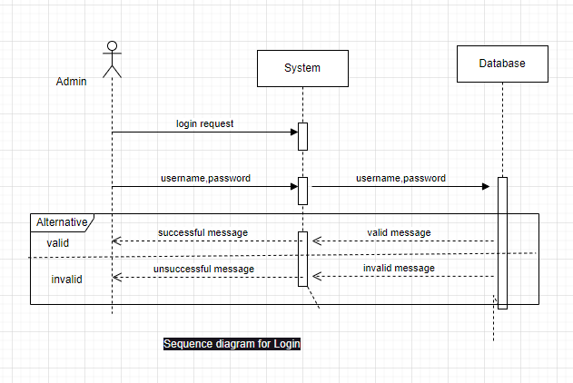

***Figure 4.15:Sequence diagram for admin login***

**4.6.2Sequence diagram for cancel booking for customer :-**

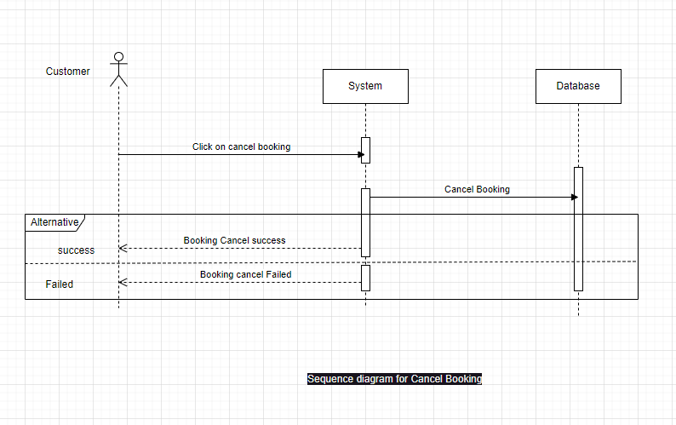

***Figure 4.16:Sequence diagram for cancel booking for customer***

**4.6.3Sequence Diagram payment method for customer :-**

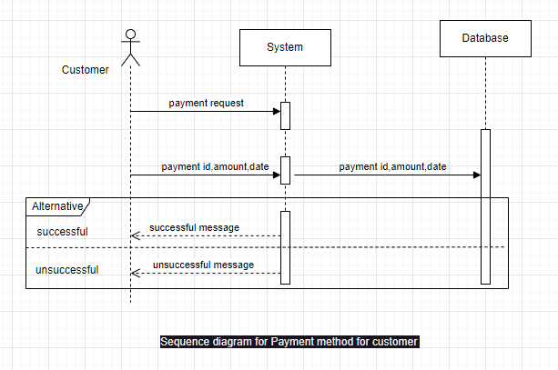

***Figure 4.17:Sequence Diagram payment method for customer***

**4.6.4Sequence diagram for Booking for customer :-**

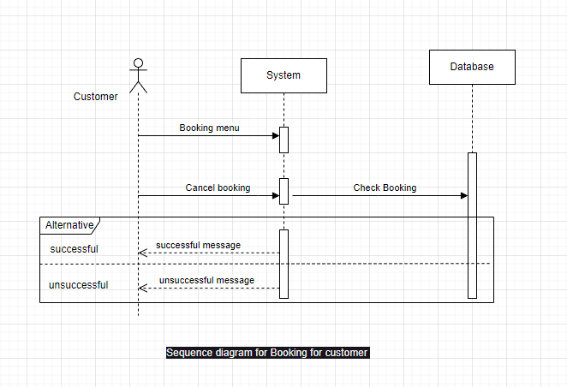

***Figure 4.18 :Sequence diagram for cancel booking for customer***

**4.6.5Sequence diagram for Check Availability for customer :-**

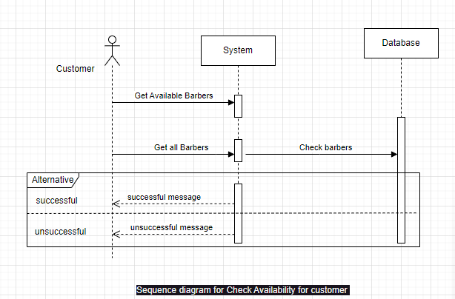

***Figure 4.19:Sequence diagram for Check availability for customer***

1. **Activity Diagram :-**

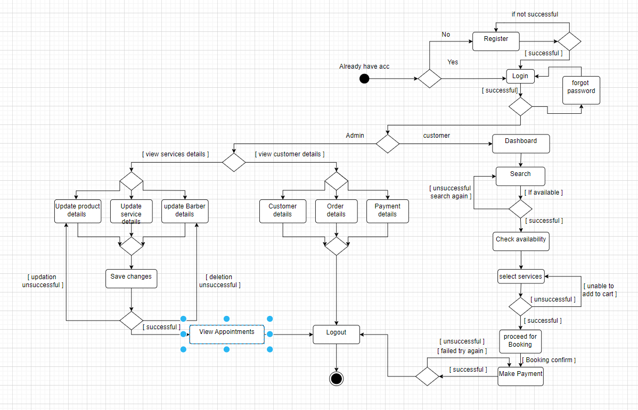

***Figure 4.20:Activity Diagram***

**User Interface :-**

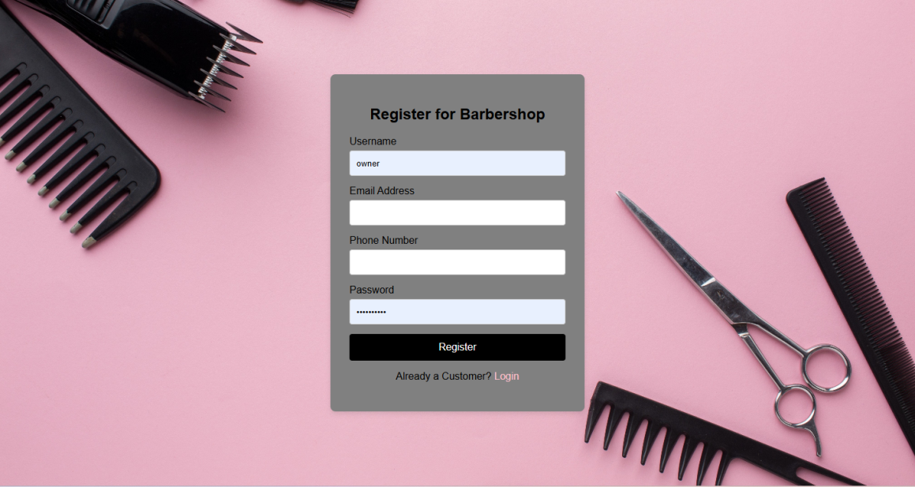

**Figure 4.21: Registration Page for Customer**

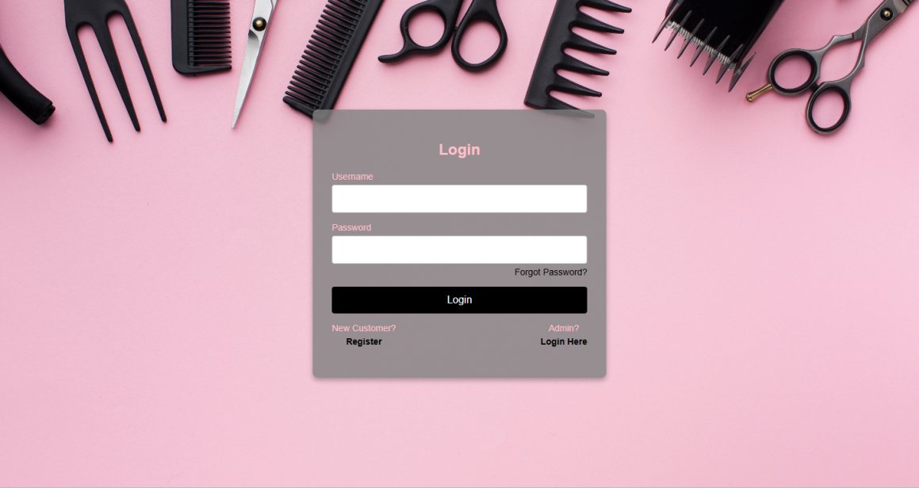

**Figure 4.22: Login Page for customer**

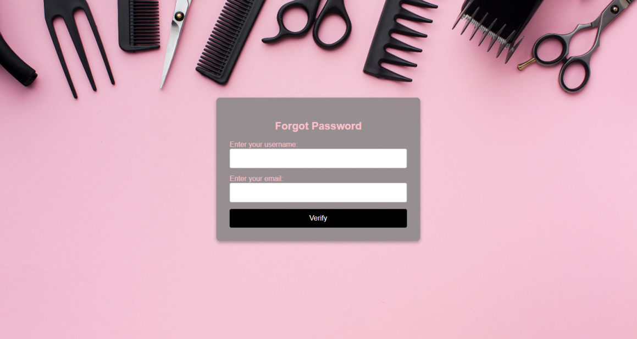

***Figure 4.23: Forgot password page for Customer***

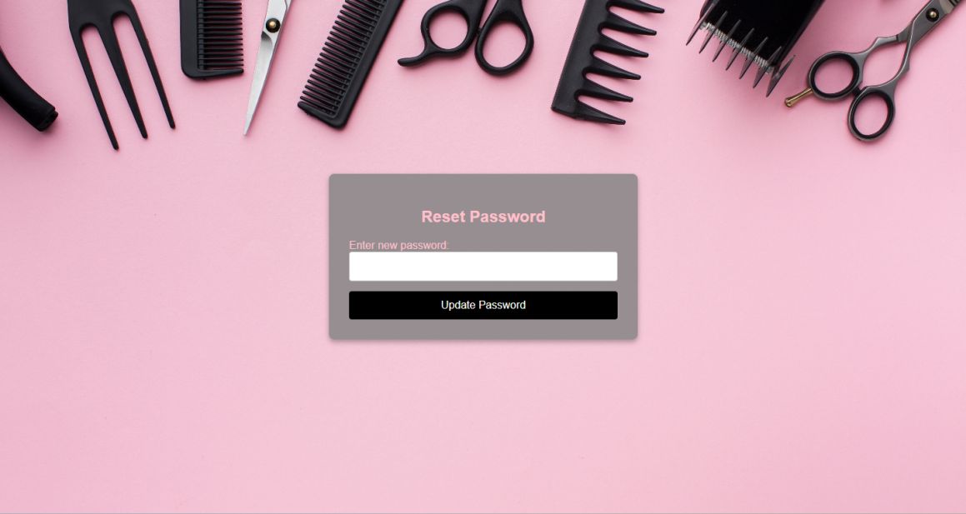

***Figure 4.24:Reset Password Page for customer***

**Customer Log:-**



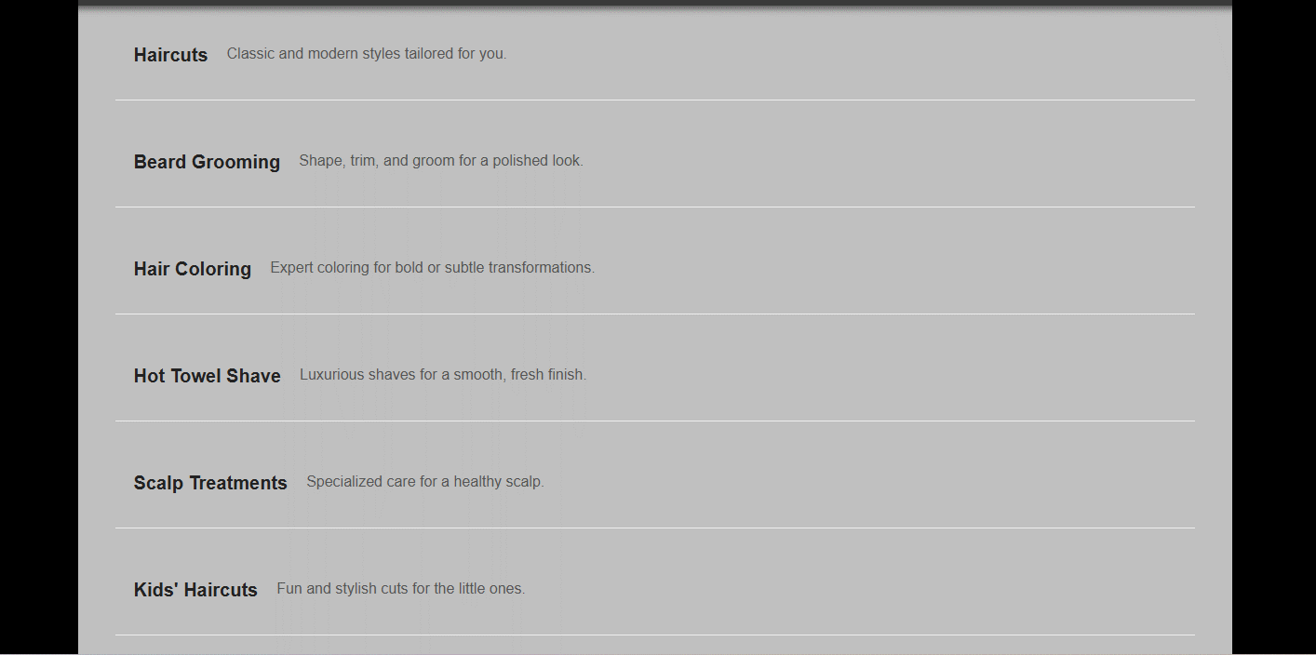

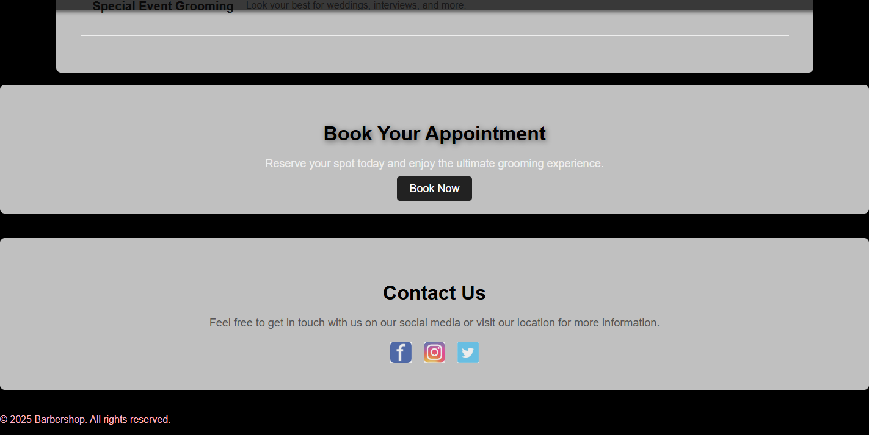

***Figure 4.25:Dashboard Page for Customer***

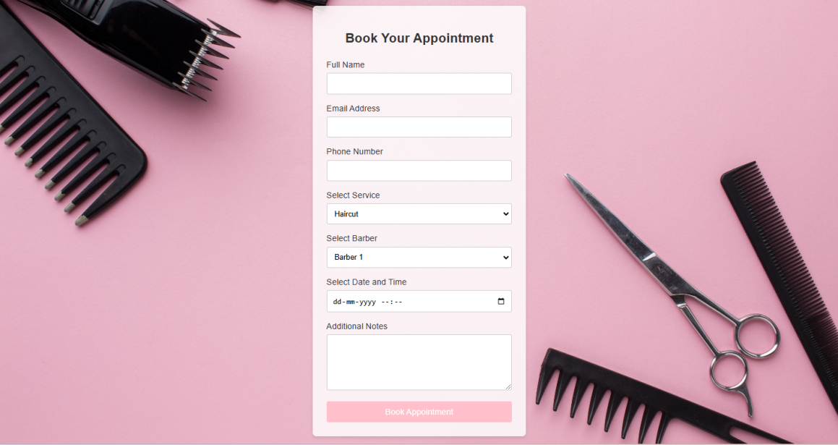

***Figure 4.26:Appointment Booking for Customer Page***

**Admin Log:-**

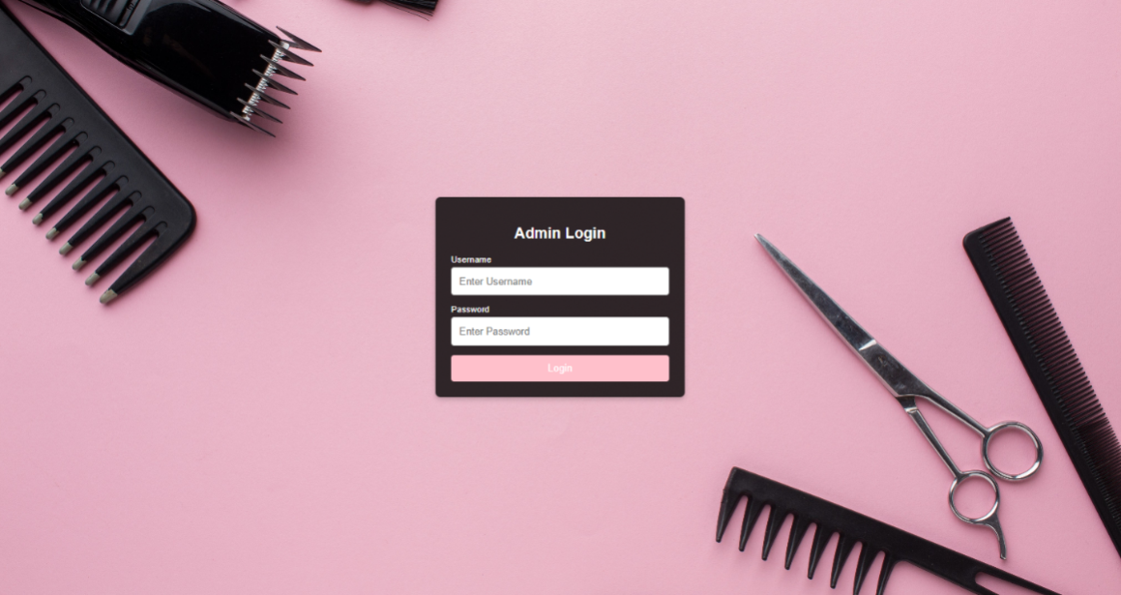

***Figure 4.27:Login Page for Admin***

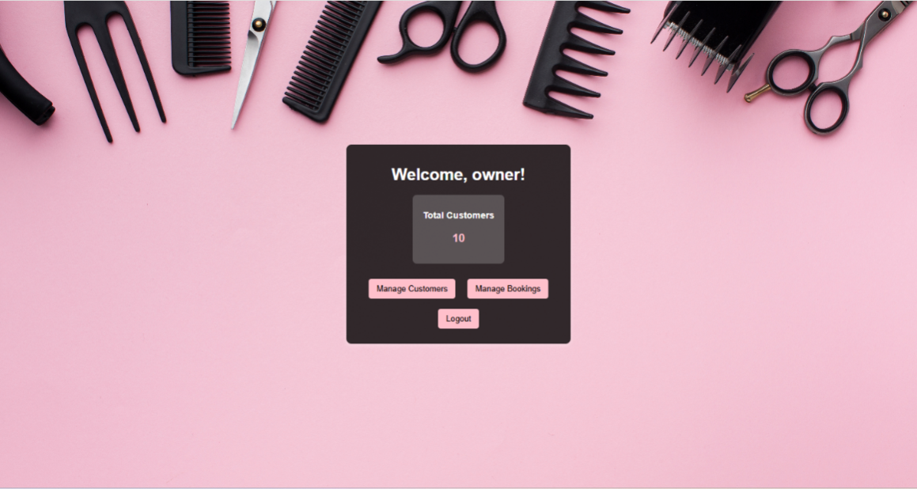

***Figure 4.28:Dashboard Page for Admin***

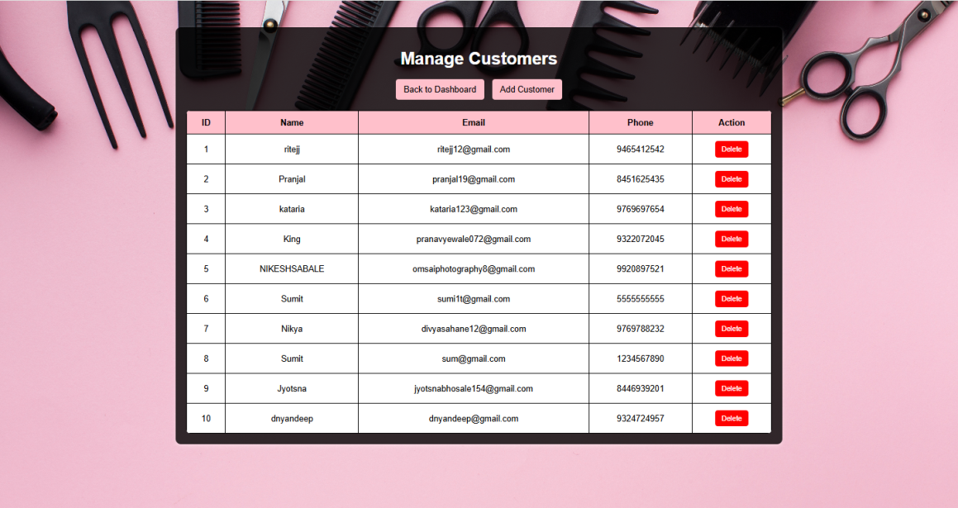

***Figure 4.29:Manage Customer for Admin***

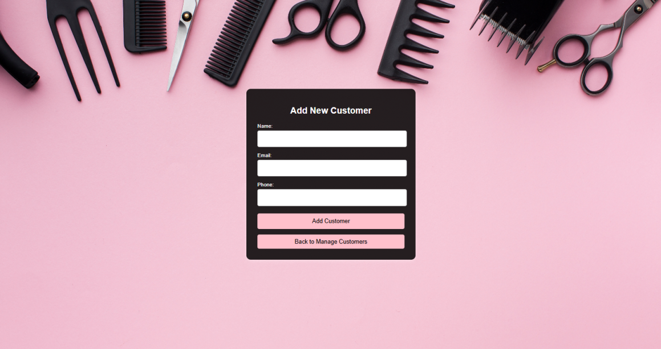

***Figure 4.30:Add Customer for Admin***

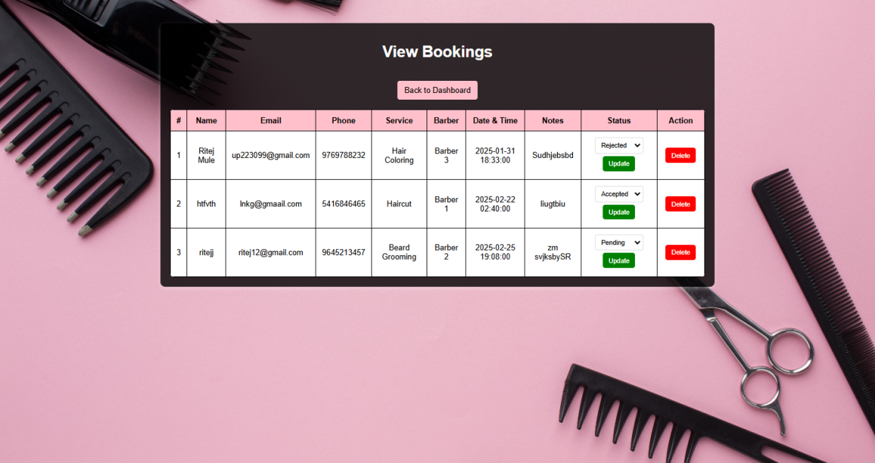

***Figure 4.31:Manage Bookings for Admin***

## **4.9 Test cases**

|  |  |  |  |  |  |
| --- | --- | --- | --- | --- | --- |
| Test case no. | Test case name | Test case value | Expected Output | Actual  Output | Remark |
| 1. | Registration | Email: Email:  Abcgmail.com | Email is not valid |  |  |
| 2. | Registration | Email: Email:  Abc@gmailcom | Registers successfully |  |  |
| 3. | Registration | Phone:  Phone: 959484869 | There must be at  least 10 integers |  |  |
| 4. | Registration | Phone:  Phone  95948486691 | Registers successfully |  |  |
| 5. | Registration | Re-enter Password:  Password: hello01 Confirm Password:  hello02 | Password doesn’t match |  |  |
| 6. | Registration | Re-enter Password:  Password: hello01 Confirm Password:  hello01 | Password matched |  |  |
| 7. | Registration | Null value | Please Fill out this field |  |  |
| 8. | Login | Email: Email:  Abcgmail.com | Email doesn’t exist |  |  |
| 9. | Login | Login: username:  abc  Password: hello01 | Login successfully |  |  |
| 10. | Login | Login: username :  abc | No user found with the given username and email |  |  |

|  |  |  |  |  |  |
| --- | --- | --- | --- | --- | --- |
|  |  | Password: hello02 |  |  |  |
| 11. | Login | Null value | Enter details for mandatory fields |  |  |
| 12. | Search | services:  Name: haircut | Search successful |  |  |
| 13. | Search | Invalid Product name: Name: 555 | No products are  visible |  |  |
| 14. | Search | Null value | Enter details for mandatory fields |  |  |
| 15. | Forget  Password | Email: Email:  Abcgmail.com | Incorrect email |  |  |
| 16. | Forget  Password | Email:  Email: null | Enter details for mandatory fields |  |  |
| 20. | Forget  Password | Re-enter Password:  Password: hello01 Confirm Password:  hello08 | Incorrect  Password/Password doesn’t match |  |  |
| 21. | Forget  Password | Re-enter Password:  Password: hello01 Confirm Password:  hello01 | Same password |  |  |
| 22. | Forget  Password | Null value | Enter details for mandatory fields |  |  |

***Table 4.1 Test Cases***

**Chapter 5 :**

**Implementation and Testing**

* 1. **Implementation approaches:**

For the development of the Barbershop Booking Management Website, the Agile Development Methodology was employed. Agile focuses on iterative progress, continuous feedback, and collaboration, making it ideal for a project with evolving user requirements and preferences. With Agile, the system is built in small, manageable chunks (sprints), allowing for quick adaptations to user feedback and feature requests. This approach enables the development team to remain flexible and responsive throughout the project lifecycle.

Each sprint involved the following phases:

Requirements Gathering: Engaging with barbershop staff, customers, and administrators to understand their needs for appointment scheduling, payment processing, customer management, and more.

Design: Creating wireframes and user interface designs that prioritize ease of use and seamless interaction between users and the booking system.

Implementation: Developing features such as appointment booking, real-time availability checking, customer profiles, payment gateway integration, and notifications for appointment reminders.

Testing: Conducting functional and usability tests to ensure smooth booking flows, secure transactions, and overall system stability.

The website’s frontend was developed using HTML, CSS, and JavaScript to create a user-friendly and responsive interface. PHP was used for the backend development to handle server-side logic and process booking information, manage user data, and interact with the database. For storing customer, appointment, and transaction data, SQL was chosen as the relational database management system.

Once the system was fully integrated, comprehensive testing was performed to validate all functionalities, including appointment creation, modification, cancellations, payment, and notification systems. The system was also thoroughly tested for scalability, ensuring it could handle peak traffic without issues. Regular iterations ensured that any potential bugs or issues were quickly identified and resolved, leading to a refined, user-friendly final product.

* 1. **Coding Details and efficiency:** 
     1. **Coding**

**Database Connection code (db_connect.php)-**

<?php

$servername = "sql113.infinityfree.com";

$db_username = "if0_38301835";

$db_password = "9769788232";

$dbname = "if0_38301835_barbershop_management";

$conn = new mysqli($servername, $db_username, $db_password, $dbname);

if ($conn->connect_error) {

die("Connection failed: " . $conn->connect_error);

}

?>

**Backend page of login page (index.php)-**

<?php

session_start();

include 'db_connect.php';

if ($_SERVER["REQUEST_METHOD"] === "POST") {

$username = $_POST["username"]; // Can be username or email

$password = $_POST["password"];

$sql = "SELECT * FROM customer WHERE username = ? OR email = ?";

$stmt = $conn->prepare($sql);

$stmt->bind_param("ss", $username, $username);

$stmt->execute();

$result = $stmt->get_result();

if ($result->num_rows> 0) {

$user = $result->fetch_assoc();

if (password_verify($password, $user['password'])) {

session_start();

$_SESSION['user'] = $user;

header("Location: dashboard.php");

exit();

} else {

echo "<script>

alert('Invalid password. Please try again.');

window.location.href = 'index.html';

</script>";

}

} else {

echo "<script>

alert('No user found with the given username or email.');

window.location.href = 'index.html';

</script>";

}

$stmt->close();

}

$conn->close();

?>

**Register.php-**

<?php

session_start();

include 'db_connect.php';

if ($_SERVER["REQUEST_METHOD"] === "POST") {

$username = $_POST["username"];

$email = $_POST["email"];

$phone = $_POST["phone"];

$password = password_hash($_POST["password"], PASSWORD_BCRYPT);

$stmt = $conn->prepare("INSERT INTO customer (username, email, phone, password) VALUES (?, ?, ?, ?)");

$stmt->bind_param("ssss", $username, $email, $phone, $password);

if ($stmt->execute()) {

echo "<script>

alert('Registration successful! Welcome, " .htmlspecialchars($username) . ".');

window.location.href = 'index.html';

</script>";

} else {

echo "<script>

alert('Error: " . $stmt->error . "');

window.location.href = 'register.html';

</script>";

}

$stmt->close();

}

$conn->close();

?>

**forgot_password.php-**

<?php

session_start();

include 'db_connect.php';

if ($_SERVER["REQUEST_METHOD"] == "POST") {

$email = $_POST["email"];

$username = $_POST["username"];

$stmt = $conn->prepare("SELECT * FROM customer WHERE email = ? AND username = ?");

$stmt->bind_param("ss", $email, $username);

$stmt->execute();

$result = $stmt->get_result();

if ($result->num_rows> 0) {

// Redirect to reset password page with the username as a URL parameter

header("Location: reset_password.php?username=" . urlencode($username));

exit();

} else {

echo "<script>alert('No user found with this email and username.'); window.location.href = 'forgot_password.php';</script>";

}

}

$conn->close();

?>

**reset_password.php-**

<?php

session_start();

include 'db_connect.php';

$username = isset($_GET['username']) ? $_GET['username'] : '';

if ($_SERVER["REQUEST_METHOD"] == "POST") {

$new_password = password_hash($_POST["new_password"], PASSWORD_BCRYPT);

$username = $_POST["username"];

$stmt = $conn->prepare("UPDATE customer SET password = ? WHERE username = ?");

$stmt->bind_param("ss", $new_password, $username);

if ($stmt->execute()) {

echo "<script>alert('Password updated successfully!'); window.location.href = 'index.html';</script>";

} else {

echo "<script>alert('Failed to update password.'); window.location.href = 'reset_password.php?username=" . urlencode($username) . "';</script>";

}

}

$conn->close();

?>

**Dashboard.php-**

<?php

session_start();

if (isset($_GET['logout'])) {

session_unset(); // Unset all session variables

session_destroy(); // Destroy the session

header("Location: index.html"); // Redirect to the login page

exit();

}

if (!isset($_SESSION['user'])) {

header("Location: index.html"); // Redirect to login page if not logged in

exit();

}

$user = $_SESSION['user'];

?>

**Booking.php-**

<?php

session_start();

include 'db_connect.php';

if ($_SERVER["REQUEST_METHOD"] == "POST") {

// Collect and sanitize data from the form

$name = htmlspecialchars($_POST['name']);

$email = htmlspecialchars($_POST['email']);

$phone = htmlspecialchars($_POST['phone']);

$service = htmlspecialchars($_POST['service']);

$barber = htmlspecialchars($_POST['barber']);

$datetime = htmlspecialchars($_POST['datetime']);

$notes = htmlspecialchars($_POST['notes']);

$sql = "INSERT INTO bookings (name, email, phone, service, barber, datetime, notes)

VALUES (?, ?, ?, ?, ?, ?, ?)";

if ($stmt = $conn->prepare($sql)) {

$stmt->bind_param("sssssss", $name, $email, $phone, $service, $barber, $datetime, $notes);

if ($stmt->execute()) {

echo "<script>

alert('Your appointment has been successfully booked! We will confirm your booking shortly.');

window.location.href = 'dashboard.php'; // Redirecting to the dashboard

</script>";

} else {

echo "<script>alert('There was an issue with your booking. Please try again later.');</script>";

}

$stmt->close();

} else {

echo "<script>alert('Error preparing the booking request. Please try again later.');</script>";

}

} else {

header("Location: booking.html");

exit();

}

$conn->close();

?>

**Admin log (admin_login.php)-**

<?php

include 'db_connect.php';

if ($_SERVER["REQUEST_METHOD"] == "POST") {

$username = $_POST['username'];

$password = $_POST['password'];

if (empty($username) || empty($password)) {

die("Please enter both username and password.");

}

$stmt = $conn->prepare("SELECT * FROM admins WHERE username = ? AND password = ?");

$stmt->bind_param("ss", $username, $password);

$stmt->execute();

$result = $stmt->get_result();

if ($result->num_rows == 1) {

$_SESSION['admin'] = $username; // Store session

header("Location: admin_dashboard.php"); // Redirect to admin panel

exit();

} else {

echo "Invalid username or password.";

}

$stmt->close();

}

?>

**Admin_dashboard.php-**

<?php

session_start();

include 'db_connect.php';

if (!isset($_SESSION['admin'])) {

header("Location: admin_login.html");

exit();

}

$customer_result = $conn->query("SELECT COUNT(*) AS total_customers FROM customer");

$customer_count = $customer_result->fetch_assoc()['total_customers'];

?>

**manage_customer.php-**

<?php

session_start();

include 'db_connect.php';

if (!isset($_SESSION['admin'])) {

header("Location: admin_login.html");

exit();

}

if ($_SERVER["REQUEST_METHOD"] == "POST" &&isset($_POST['delete'])) {

$id = $_POST['id'];

$conn->query("DELETE FROM customer WHERE id = $id");

$conn->query("SET @count = 0;");

$conn->query("UPDATE customer SET id = @count := @count + 1;");

$conn->query("ALTER TABLE customer AUTO_INCREMENT = 1;");

header("Location: manage_customers.php");

exit();

}

$result = $conn->query("SELECT * FROM customer ORDER BY id ASC");

?>

**view_bookings.php-**

<?php

session_start();

include 'db_connect.php';

if (!isset($_SESSION['admin'])) {

header("Location: admin_login.html");

exit();

}

$result = $conn->query("SELECT * FROM bookings");

if ($_SERVER["REQUEST_METHOD"] == "POST" &&isset($_POST['update'])) {

$id = $_POST['id'];

$status = isset($_POST['status']) ? $_POST['status'] : 'Pending';

$conn->query("UPDATE bookings SET status = '$status' WHERE id = $id");

header("Location: view_bookings.php");

exit();

}

if ($_SERVER["REQUEST_METHOD"] == "POST" &&isset($_POST['delete'])) {

$id = $_POST['id'];

$conn->query("DELETE FROM bookings WHERE id = $id");

header("Location: view_bookings.php");

exit();

}?>

**5.2.2 Code Efficiency:**

Code efficiency is crucial for ensuring that the website runs smoothly, loads quickly, and provides a seamless user experience. To achieve this, the website uses optimized database queries by structuring tables efficiently to prevent duplicate data storage. Frequently queried columns, such as appointment dates, barbers, and customer details, are indexed to speed up data retrieval and minimize query time.

To keep the code clean and efficient, unnecessary repetitions are avoided by utilizing reusable functions and code modules across different parts of the website. Loops and conditions are optimized, reducing processing time and ensuring better overall performance. Image handling is also improved by resizing and compressing images before storing them, helping reduce loading times significantly. Lazy loading is implemented so that images and heavy content are only loaded when they come into the user's viewport, further improving page speed and overall performance.

Since the website does not use AJAX for form submissions, it relies on server-side processing to handle booking data and customer interactions efficiently. To enhance security, proper form validation is in place to reduce unnecessary server requests caused by invalid or incomplete input. These optimizations contribute to a fast, secure, and user-friendly experience for both customers and barbers.

**5.3 Testing Approaches:**

Testing for the Barbershop Booking Management Website follows a structured approach that aligns with its system design to ensure all features function correctly. Functional Testing is carried out to check whether key features, such as appointment booking, user registration, and notifications, work as expected. User-Acceptance Testing (UAT) is conducted with real users, including barbers and customers, to assess whether the website is intuitive and easy to use. Feedback is gathered on important aspects such as the booking process, payment gateway functionality, and communication with barbers, ensuring a smooth and efficient user experience.

To test how the website handles different types of appointments, Category Partition Testing is performed. This ensures that appointments are filtered and displayed according to their type (e.g., haircuts, shaves, or spa treatments). State Machine-Based Testing is used to verify features like appointment status updates, user notifications, and the availability of barbers. This ensures that actions taken by users, such as booking or canceling appointments, are accurately reflected across the entire website, maintaining consistency and reliability.  
  
  
**5.4 Unit Testing:**  
Unit testing is essential to ensure that individual components of the Barbershop Booking Management Website function correctly. The Appointment Management Module is tested to verify that appointments can be booked, updated, and canceled correctly. The User Authentication Module is tested to ensure that login, registration, and session management processes work securely and as expected.  
  
The Notification Module is also tested to verify that customers receive timely reminders and updates about their appointments. Additionally, the Payment Module is tested to ensure that payments are processed securely and that transactions are recorded accurately. Unit testing tools like PHPUnit for backend logic and Jest for frontend testing can be used to automate and validate functionality throughout the website, ensuring a smooth user experience.

**(1) Registration**

|  |  |  |  |  |  |
| --- | --- | --- | --- | --- | --- |
| Test case no. | Test case name | Test case value | Expected Output | Actual  Output | Remark |
| 1. | Registration | Email: Email:  Abcgmail.com | Email doesn’t exist | @ is  missing | Pass |
| 2. | Registration | Email: Email:  Abc@gmailcom | Registers successfully | Registers successfully | Pass |
| 3. | Registration | Phone:  Phone: 959484869 | There must be at  least 10 integers | Contact no must be 10  digits | Pass |
| 4. | Registration | Phone:  Phone:  95948486691 | Registers successfully | Registers successfully | Pass |
| 5. | Registration | Password:  Password: hello01 | Password mustbe 4 characters long | Password doesn’t match | Pass |
| 6. | Registration | Re-enter Password:  Password: hello01 | Password matched | Registers successfully | Pass |
| 7. | Registration | Null value | Enter details for mandatory fields | Enter all  fields | Pass |

## *Table 5.1 Unit Testing of Registration*

1. **Login**

|  |  |  |  |  |  |
| --- | --- | --- | --- | --- | --- |
| Test case no. | Test case name | Test case value | Expected Output | Actual  Output | Remark |
| 1. | Login | Username:  abc | Username doesn’t exist | User must enter the  email again | Pass |
| 2. | Login | Login: Username:  abc  Password: hello01 | Login successfully | User redirects to dashboard. | Pass |
| 3. | Login | Login:Username:  abc  Password: hello02 | Username does not exist | Username does not exist | Pass |
| 4. | Login | Null value | Enter details for mandatory fields | User must enter all  fields | Pass |

***Table 5.2 Unit Testing of Login***

1. **Forgot password**

|  |  |  |  |  |  |
| --- | --- | --- | --- | --- | --- |
| Test case no. | Test case name | Test case value | Expected Output | Actual  Output | Remark |
| 1. | Forget  Password | Email: Email:  Abcgmail.com/  Abc@gmail.com | Incorrect email | Email not found | Pass |
| 2. | Forget  Password | Email:  Email: null | Enter details for mandatory fields | Fill out this field | Pass |
| 3. | Forget  Password | Username:  Username: abc | Incorrect username | Username not found | Pass |
| 4. | Forget  Password | Username:  Username: Null | Enter details for mandatory fields | Fill out this field | Pass |
| 6. | Reset password | Enter Password:  Password: hello01 | Password must be at least 4 characters long | Password  do not  match | Pass |
| 7. | Reset  Password | Re-enter Password:  Password: hello01 | Password change successfully | Resets the password and redirects to login page | Pass |

*Table 5.3 Unit Testing of Forgot Password*

**CHAPTER 6:**

**RESULTS AND DISCUSSIONS**

**6.1 Test Reports**

Testing plays a crucial role in ensuring the reliability and functionality of the Barbershop Booking Management website. Throughout the testing phase, the primary focus was on validating the smooth operation of all essential components, including appointment booking, user authentication, barber management, and payment processing. A comprehensive testing plan was devised to cover every aspect of the website, ensuring that all features operated seamlessly under various conditions.

By simulating different user scenarios, the system was rigorously evaluated to test its performance in real-world situations. This included testing the booking process for customers, the admin panel for barbershop staff, and the integration of payment gateways. The testing phase provided valuable insights into areas that could be improved to enhance the overall user experience. For example, issues related to real-time barber availability updates and session persistence during appointment booking were identified, leading to optimizations that improved both functionality and usability. Despite these minor challenges, the core features of the website—including appointment creation, payment processing, and customer-barber communication—functioned flawlessly.

The insights gained from testing led to several refinements, such as improving the navigation flow, ensuring the accuracy of the appointment scheduling system, and optimizing the database queries for faster data retrieval. These improvements helped create a more efficient and user-friendly experience. The integration of email and SMS notifications also underwent thorough testing to ensure timely reminders and confirmations, resulting in a smoother booking process for customers.

Ultimately, the testing process confirmed the website’s ability to handle diverse user interactions effectively, ensuring its robustness and reliability in real-world usage. The website was successfully validated against a wide range of user scenarios, confirming that both customers and barbershop staff could navigate the system with ease, book appointments efficiently, and make payments securely, all while enjoying a seamless user experience.

**6.2 User Documentation:**

**1. Login page (It is the first page opens when Customers visits the website link)**



**Figure 6.1: Login Page for customer**

**Functionality:** It authenticates users by verifying their email and password against the database. It includes form validation, error handling, session management, and options for password recovery and registration.

**2. Registration page for Customers and Artists (On clicking Don’t have an account?**

**Register here.)**



**Figure 6.2: Registration Page for Customer**

**Functionality:** The registration page allows new users to create an account by providing their details, including name, email, contact number, address, password, and role selection. It includes form validation, password confirmation, and stores user data securely in the database.

Users can navigate to the login page if they already have an account.

**3. Forgot Password for Customers and Artists (On clicking Forgot Password? in the login page, the Forgot Password page will get open)**



***Figure 6.3: Forgot password page for Customer***

**Functionality:** The "Forgot Password" page allows users to reset their password by entering their registered username and email. A System checks that username and Email already exist in the database to proceed with setting a new password securely.

**4. Reset Password for Customers (On clicking on “Reset Password” button, the Verify Username and Email page will open)**



***Figure 6.4:Reset Password Page for customer***

**Functionality:** The verified username and Email registered in the datavbase. Upon successful verification, they can proceed with password reset or account recovery.

**Customer Log:-**

**5.Dashboard Page for Customer**







***Figure 6.5:Dashboard Page for Customer***

**Functionality:**The dashboard page of the barbershop allows customer to Search the services get about and contact page also redirects to the booking page

**6.Appointment Booking for Customer:**



***Figure 6.6:Appointment Booking for CustomerPage***

**Functionality:**Customer books an appointment through the booking page. There is some validation while filling the personal details in the appointment booking form.

**Admin Log:-**

**7.Admin Login page:**



***Figure 6.7:Login Page for Admin***

**Functionality:** Admin can login through page and after that admin will redirects to the admin dashboard page.

**8.Admin Dashboard page**



***Figure 6.8:Dashboard Page for Admin***

**Functionality:** Admin dashboard page shows admin the number of total registered customers and also can manage the customers and also can manage the services the redirection button is in the page.

**9.Manage Customers Page:**



***Figure 6.9:Manage Customer for Admin***

**Functionality:**  Admin can manage the customers through this page can delete the already customer and can also add the new customer.

**10.Add customer page:**



***Figure 6.10:Add Customer for Admin***

**Functionality:** Admin after clicking on the Add customer button in the Manage customer page and redirecting here to add the new unregistered customers.

**11. View Bookings:**



***Figure 6.11:Manage Bookings for Admin***

**Functionality:** View Bookings page where admin can view recent bookings their payment status customer barber and service selected by the customer and the time when the customer wants the service, Admin can update the payment status and delete the bookings.

### CHAPTER 7:

### CONCLUSION AND FUTURE WORK

#### **7.1 Conclusion:**

The Barbershop Booking Management website provides a streamlined platform for customers to easily book appointments with barbers, while also enabling barbershop owners to manage their staff, services, and appointments efficiently. The system allows customers to browse available barbers, view their profiles, and book appointments based on their preferences, such as service type and timing. Barbershop staff can manage their schedules, track upcoming appointments, and communicate with clients, all through a user-friendly interface.

The booking system ensures convenience for customers by offering real-time availability checking and sending automated reminders for upcoming appointments. Secure payment integration provides a seamless and secure checkout experience, allowing customers to pay for services online. Additionally, a customer review and rating system is implemented to help other users make informed decisions when choosing a barber.

The platform's ability to handle multiple services, such as haircuts, shaves, and other grooming services, allows for flexibility and caters to the varying needs of customers. The direct messaging feature strengthens communication between customers and barbers, enabling them to clarify service details or ask questions before their appointment. Overall, the website bridges the gap between barbers and customers, providing an efficient and modern solution for booking and managing salon services.

#### **7.2 Limitations of the System:**

While the Barbershop Booking Management website offers a seamless user experience, there are certain limitations that may affect its functionality and user satisfaction:

* **No Real-time Appointment Tracking:** Customers cannot track the status of their appointments in real-time, which may lead to confusion regarding scheduling or delays.
* **Limited Payment Options:** The system currently supports a limited number of payment gateways, restricting customer flexibility in selecting their preferred payment method.
* **Absence of Live Chat Support:** Communication between customers and barbers is limited to email or messaging features, rather than real-time chat, potentially causing delays in responses.
* **Manual Updates for Barber Availability:** Barbers need to manually update their availability, which can lead to potential discrepancies or errors in scheduling.
* **No Personalized Recommendations:** The platform does not offer personalized suggestions based on customer preferences or past bookings, which could enhance the user experience and increase engagement.

#### **7.3 Future Scope of the Project:**

The Barbershop Booking Management website can be significantly enhanced in several ways to improve user experience and broaden its functionality:

* **Real-time Appointment Tracking:** Implementing real-time tracking for customers to check the status of their appointments, such as wait times or the current status of their barber.
* **Expanded Payment Options:** Adding more payment gateways, such as mobile wallets or international payment methods, to give customers greater flexibility in payment choices.
* **Live Chat Support:** Integrating live chat functionality to allow instant communication between customers and barbers, improving response time and customer satisfaction.
* **Automated Barber Availability Management:** Implementing a system that automatically updates barber availability based on their work hours, breaks, and appointments, reducing human error and enhancing scheduling accuracy.
* **AI-powered Recommendations:** Incorporating an AI-based recommendation engine that suggests services or barbers based on past customer preferences, increasing personalization and customer engagement.
* **Mobile Application Development:** Developing a dedicated mobile app for enhanced accessibility, allowing customers to easily book appointments and manage their profiles on the go.
* **International Expansion:** Expanding the platform’s reach by supporting multilingual options and international payment methods to cater to a global audience.

### References

### **Books**

1. Database System Concepts by Korth, 4th Edition.
2. Software Engineering by Ian Somerville, 8th Edition, Pearson Education.

**Websites**

1. <https://youtu.be/KN-inGJG540?si=srDSFGXV4PmIb71D> - 13/07/24
2. <https://youtu.be/VnRQ5CNC4Fs?si=z3-8oG3iOxR6jIVS> - 11/08/24
3. <https://youtu.be/LyhTDsjjjrE?si=I3msk3m5rtKcJmVW> - 4/09/24
4. [Geeks for Geeks](https://www.geeksforgeeks.org/) - 22/06/24 to 4/09/24
5. [YouTube](https://www.youtube.com/) - 22/06/24 to 27/02/25
6. [Google](https://www.google.co.in/) - 22/06/24 to 27/02/25